Scripts Section:

Network info dump script
https://github.com/gabemor/LinuxAdmin-Portfolio/blob/main/network%20info%20dump%20script

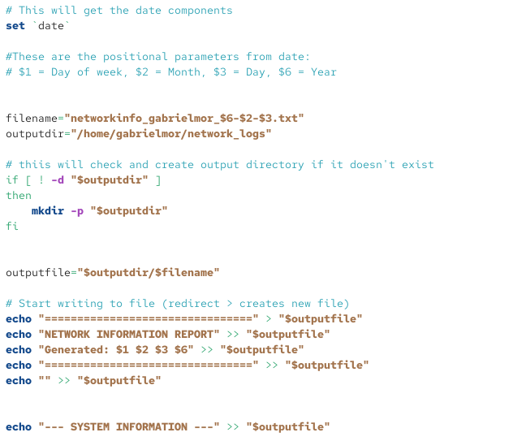
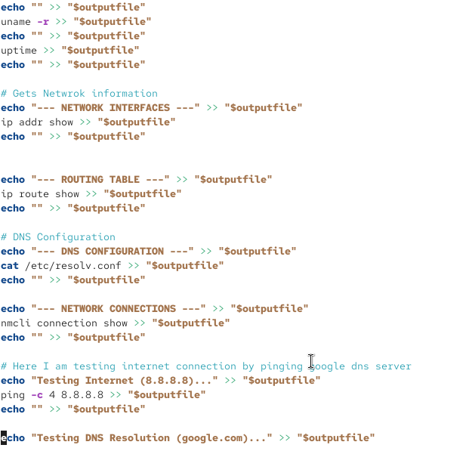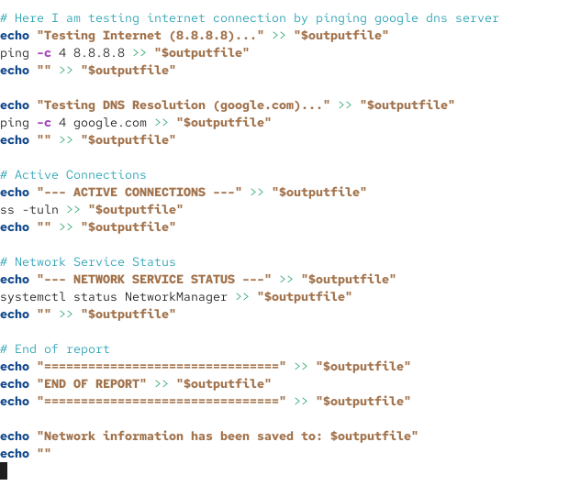

Network troubleshoot script
https://github.com/gabemor/LinuxAdmin-Portfolio/blob/main/network%20troubleshooting%20script

